Progressive Newton 2019 Candidate Endorsements

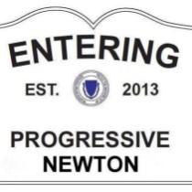

We are excited to announce that Progressive Newton has endorsed fifteen excellent candidates in contested local races this fall.
All of Newton can vote for these candidates:

Newton City Council (At-Large)

Susan Albright, Ward 2
Jake Auchincloss, Ward 2
Andrea Kelley, Ward 3
Deb Crossley, Ward 5
Andrea Downs, Ward 5
Alicia Bowman, Ward 6
Vicki Danberg, Ward 6

Newton School Committee

Tamika Olszewski, Ward 4
Emily Prenner, Ward 5
Ruth Goldman, Ward 6

Residents of the candidates' wards also can vote for these candidates:

Newton City Council (Ward-Only Seats)

Maria Scibelli Greenberg, Ward 1
Bryan Barash, Ward 2
Carolina Ventura, Ward 3
Bill Humphrey, Ward 5
Brenda Noel, Ward 6

Newton is fortunate to have so many talented and progressive residents willing to serve in public office.

We urge you to look for these candidates around town, and to vote for them on Tuesday, November 5th. They will serve Newton well.

